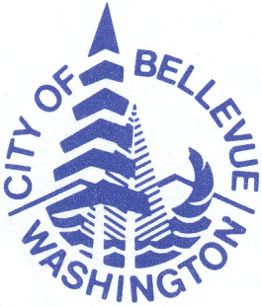
City of Bellevue Parks & Community Services
Amendment to Pass Holder Agreement
North Bellevue Community Center

ALL REQUESTS FOR CANCELLATIONS, AMENDMENTS, OR HOLDS MUST BE SUBMITTED IN PERSON IN WRITING 10 DAYS PRIOR TO DATE OF CANCELLATION, AMENDMENT, OR HOLD. NO REFUND OR CREDIT WILL BE ISSUED BETWEEN DATE OF REQUEST AND EFFECTIVE DATE

This pass is non-transferable and the primary pass member is liable for the financial obligation of this Agreement regardless of whether or not they utilize the facility.
Pass holders will not be credited due to lack of use of the facility.

Fitness Passes Only:
- Holds may be placed on any pass for a minimum of one month and a maximum of two months per calendar year, for any reason.
- A $5.00 transaction fee will be charged for each hold or change in pass Plan/Type.
- All pass holder agreements require a minimum obligation of six full months.
- If the automatic payment is cancelled before that time for any reason, the primary pass holder will be prohibited from setting up another automatic payment for a period of 12 months from the date it was first set up.

Main Participant Name:

Address: Phone: ( ) -

Cancellation

Reason (please check one):

Class or personal schedule changed
Financial Reasons
Medical
Moved
Not using
Using another gym

Other:

Hold From Date: To Date:
Change in Status/Type From: To:

Signature Date

For Office Use Only

Received Date: Effective Date:

CSR Signature: Coordinator:
Pass Type: Length of Pass: Tracked: Copied:

