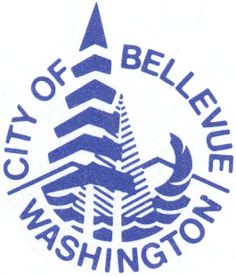
City of Bellevue
Parks & Community Services
Parks Scheduling Office
PO Box 90012
Bellevue, WA 98009-9012

POST-SEASON LEAGUE REPORT
Print or type:

Organization: Contact Person:
For Season (check one): Spring Summer Fall Winter
Please complete the chart below, using one line for each division. More copies available if additional lines are needed.
 | Participation Update |  |  | Activity Update |  |  |  | Other
 | Division  (Age, Level, Gender, etc…) | # of Teams | # of Players | # of Games per Team | # of Practices per Week | Date of First Practice | Date of First Game | Other
 | *Example* T-Ball/Shetland | 10 | 130 | 10 | 2 | 3/1/11 | 4/2/11
This Year's Opening Ceremony Date:
Opening Date for Next Year's Registration:
Additional Comments:

