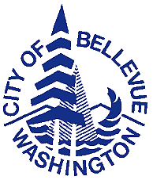
City of Bellevue

D i s a b i l i t y B o a r d

Agenda Regular Meeting
City Hall, Conference Room 1E-118

Date: Tuesday, April 5, 2016

Time: 5:30 pm Administrative Meeting
6:00 pm Business Meeting

Call to Order

Roll Call

- Public Comment

- Approval of Minutes of Regular Meetings, March 1, 2016

V. Consideration of Applications for Disability Allowances

- Applications for Disability Allowances
  - Fire Department

B. Applications for Disability Allowances Greater than 1 month
1) Fire Department

VI. Consideration of Medical Claims

Routine claims

Special claims

Pre-Approved Recurring Long-Term Care Claims

VII. Staff Reports

VIII. Unfinished Business

IX. New Business

X. Announce Date & Time of next meeting: Tuesday, April 5, 2016

XI. Adjournment

