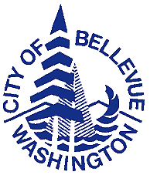
City of Bellevue

D i s a b i l i t y B o a r d

Agenda Regular Meeting
City Hall, Conference Room 1E-118

Date: Tuesday, January 5, 2016

Time: 5:30 pm Administrative Meeting
6:00 pm Business Meeting

Call to Order

Roll Call

- Approval of Minutes of Regular Meetings, December 1, 2015

IV. Consideration of Applications for Disability Allowances

- Applications for Disability Allowances
  - Fire Department

B. Applications for Disability Allowances Greater than 1 month
1) Fire Department

V. Consideration of Medical Claims

Routine claims

Special claims

Pre-Approved Recurring Long-Term Care Claims

VI. Staff Reports

VII. Unfinished Business

VIII. New Business

IX. Announce Date & Time of next meeting: Tuesday, February 2, 2016

X. Adjournment

